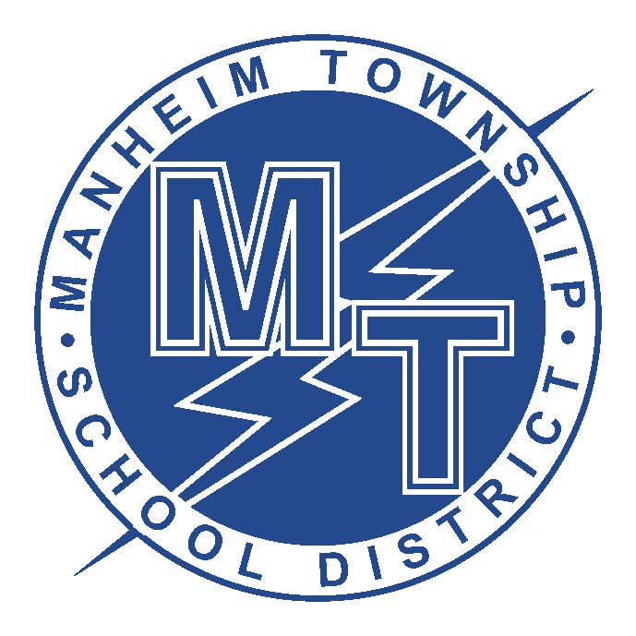
Title I Frequently Asked Questions
Manheim Township School District

What is Title 1?

Title 1 is a federally funded program designed to help schools provide supplemental services to students having academic difficulties. Manheim Township uses these funds at our middle school to provide students with additional math and reading support. These classes provide students with additional time and assistance in order to help students with the reading and math difficulties. In addition, the Title 1 Program provides the middle school the ability to have two teachers present during a portion of each math and reading support class. Finally, the Title 1 Program enables the middle school to purchase instructional technology such as computers and computer software to assist students in their learning.

What are my rights to information about my child’s teachers?

As a recipient of Title 1 funds, we are required by federal law to notify you that you may request, and the district will provide upon request, information about the professional qualifications of your child’s classrooms teachers. The district will provide you with the following:
- Whether the teacher has met state qualification and licensing criteria for the grade levels and subject areas in which the teacher provides instruction.
- Whether the teacher is teaching under emergency or other provisional status through which state qualification and licensing have been waived. The baccalaureate degree major of the teacher and any other graduate certification or degree held by the teacher, and the field of discipline of the certification or degree.
- Whether the child is provided services by paraprofessionals and, if so, their qualifications.

How did my child become involved in the program?

Students are identified for Title 1 programs in a number of ways. The primary means is through their PSSA scores in combination with the GRADE reading assessment, the end-of-year mathematics exam, and prior class performance. Students who are struggling as measured by their grades and assessments will generally be referred to the program. If you have questions as to why your child has been identified for the Title 1 program, please contact Karen Evans (MT Middle School) or John Loose (MT High School).

How can I help to build our Title 1 program?

We have numerous places where we could use assistance. If you have strengths in mathematics and/or reading we could use your skills to work directly with students. We need parents to help us plan our parent activities to make sure they are meaningful and well supported. We also need parents to participate in our Title 1 committee where we consider budgeting needs and what programs to offer. If you would like to be involved please contact your building principal. We would greatly appreciate any time or assistance you can provide.

